Oppgave 3.

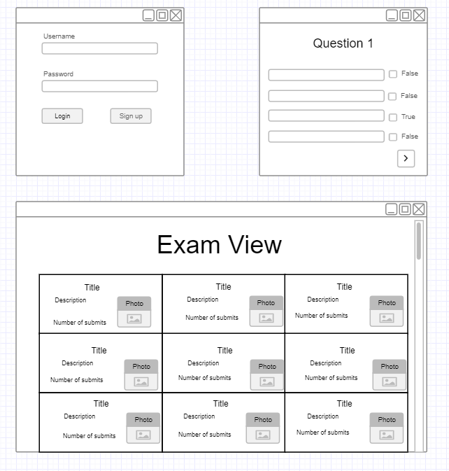

Datatabell:

|  |  |  |
| --- | --- | --- |
| **ID** | **Date** | **Passed** |
| 1231231 | 20.08.2020 | True |
| 1234556 | 20.08.2020 | False |
| 1534411 | 20.08.2020 | True |
| 1245222 | 20.08.2020 | True |
| 1679005 | 20.08.2020 | False |